Snow Shadow Sports Institute
A Division of
Snow Shadow Gymnastics
High Altitude Cross Training

535 South 1st Street * Montrose, Colorado 81401

Health & Fitness Program

* Autism * Asperger * Rett * Fragile X

* Spina bifida * Marfan Syndrome

* Myotonic Dystrophy * Cerebral Palsy

Special Interest Needs
Class Day:
Schedule for Appointment

e-mail: www.snowshadowgymnastics@yahoo.com
Website: www.snowshadowgymnasticshighaltitudecrosstraining.com
About: Snow Shadow Gymnastics Director
Bruce Kirk began gymnastics in 1969 and, is the founder and director of Snow Shadow Gymnastics sharing over 38 years of experience in the sport of Women's Olympic Style Gymnastics and Dance. Coach Kirk taught in numerous Olympic Centers in the United States as well as having the opportunity to have had numerous World level athletes under tutelage. He has provided fitness and educational programs in both public, private and parochial school systems in Ohio, Florida, Texas, Massachusetts, and Michigan and is now located in Montrose, Colorado. As early as 1979 Coach Kirk began establishing Home School programs, acting Judge for The Special Olympics, Professional Acrobatic Teams for competition and performances including Super Bowl half-time shows and a myriad of community events. In 1980 he received a Dance Master’s Degree. Many hours of his teaching skills were donated for project funding for United Way programs, the St. Augustine, FL School for Hearing Impaired, including local, state, regional, national level Jr. Olympic events and many other gratis projects throughout his career. By 1994 after meticulous research studies for ‘Health Benefits Gained while Training in a High Altitude Environment’ Coach Kirk established the "First Women's Gymnastics High Altitude Cross-Training" program of its kind in the United States. In 1999 Coach Kirk made Montrose, CO his national home base, opening the doors to Snow Shadow Gymnastics High Altitude Cross-Training and began Olympic style gymnastics instruction for both recreational and competitive levels while incorporating numerous other instructional health, educational and sport programs made available for the public.
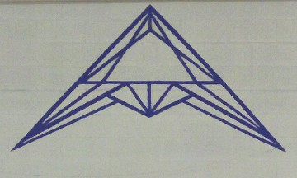

Coach Kirk is also known well for his professionalism, patience, concern and long-term devotion for all families including those afflicted with physical and mental disabilities. As well as his reputable effort researching new methods in order to continue providing a multitude of useful diversified educational and health fitness programs available for citizens in both public, and private business sectors for many communities.

Class Rules & Policies
DRESS STYLE: It is important that the children feel comfortable in the clothing style of choice, although do your best to have: Boy's; dressed in shorts and a Tee shirt. Girl's; Leotard or shorts & Tee shirt, hair must be tied back so not to interfere with vision and balance. Warm-up suits are acceptable for both boys and girls.
SAFETY RULE: NO Jewelry * Buckles * Zippers * Blue-jeans 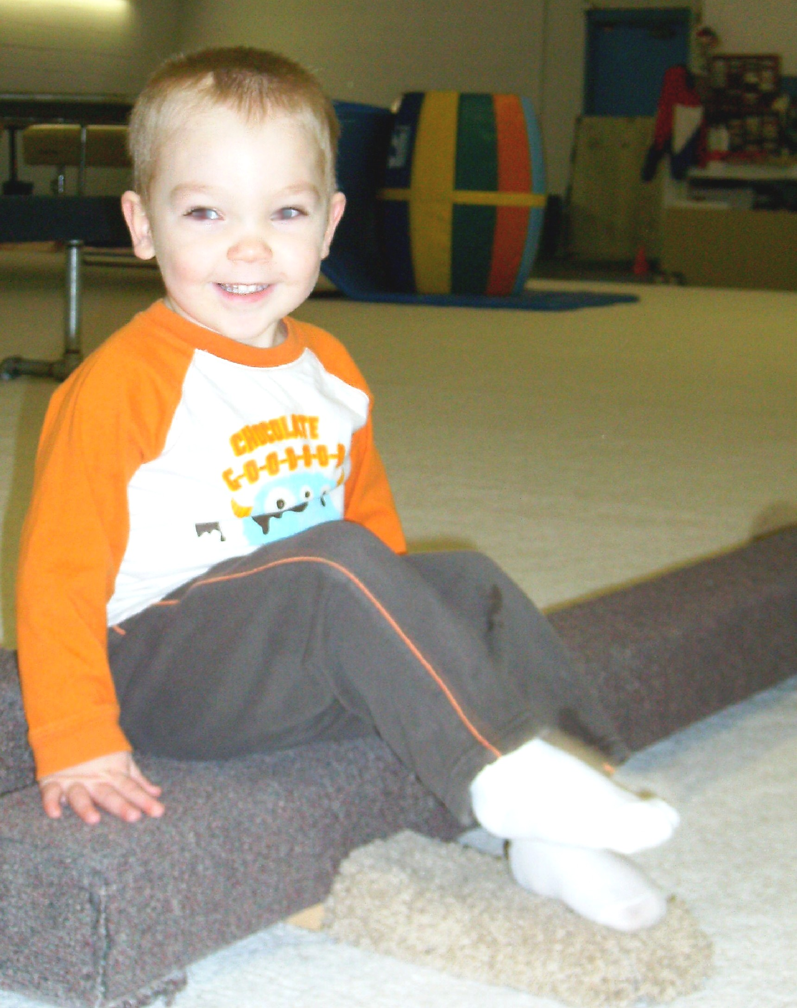 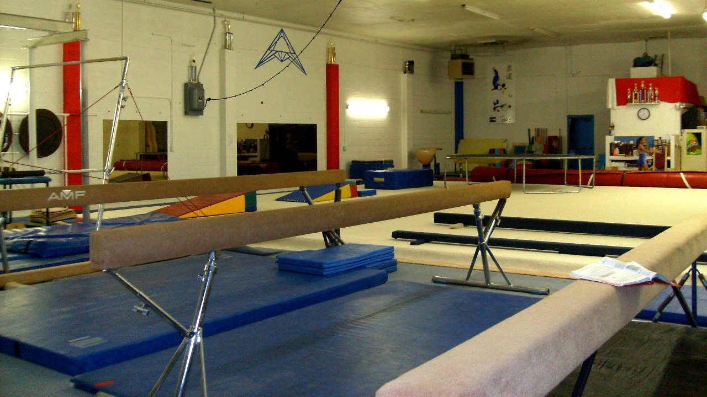 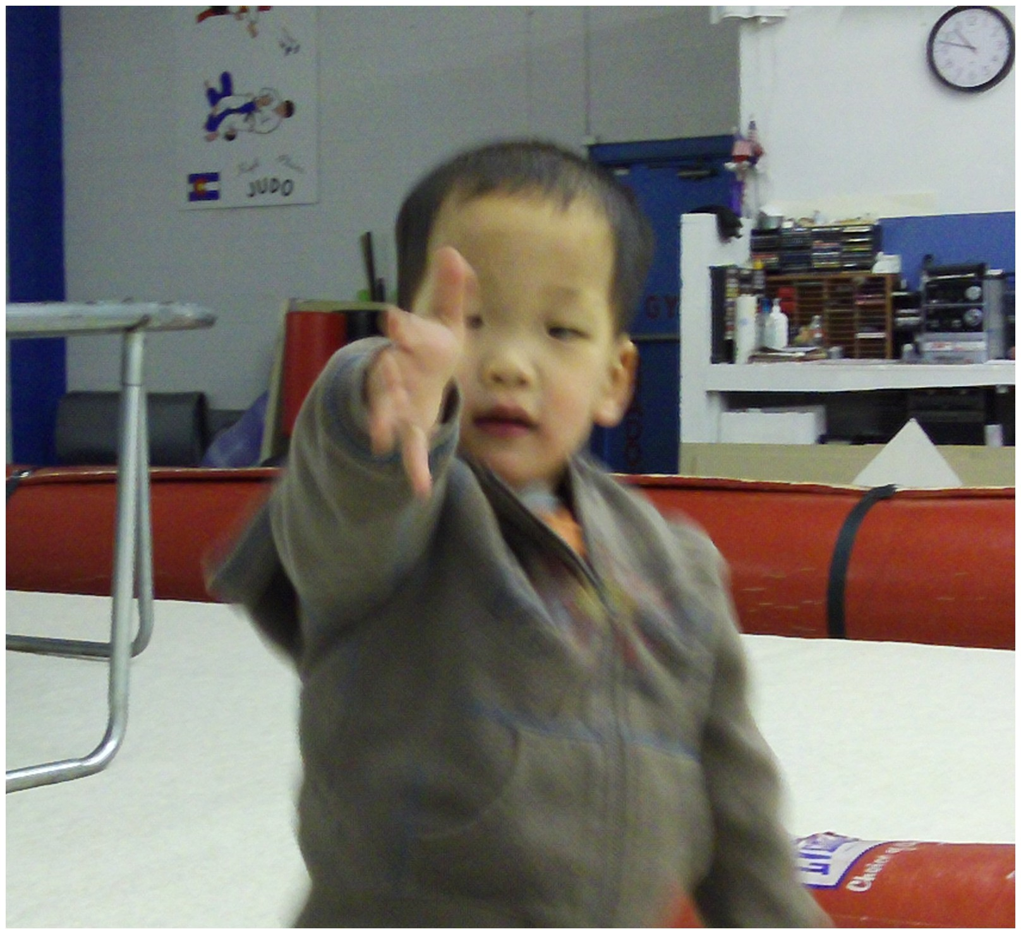
Vincent Wilson * Spina bifida Inside peek at Snow Shadow Gym Ian Miller * Fragile X

Gymnastics is a barefoot sport though socks are accepted.
Donations for Educational & Sport Scholarship funds are accepted!

